SOP for Looming system developed by Zengyou
03/17/2026
Hardware and Software:
- Computer with 2 external monitors
- USB Camera x1 with holding arm
- Laser source: Doric LD Fiber Light Source
- Customized IO box (Arduino Uno)
- Looming chamber: 40x40x32.5cm
- Customized Bonsai-RX workflow
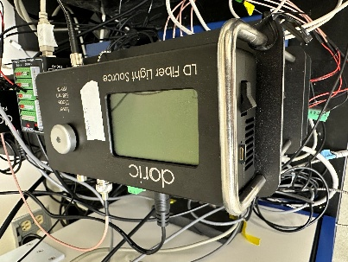
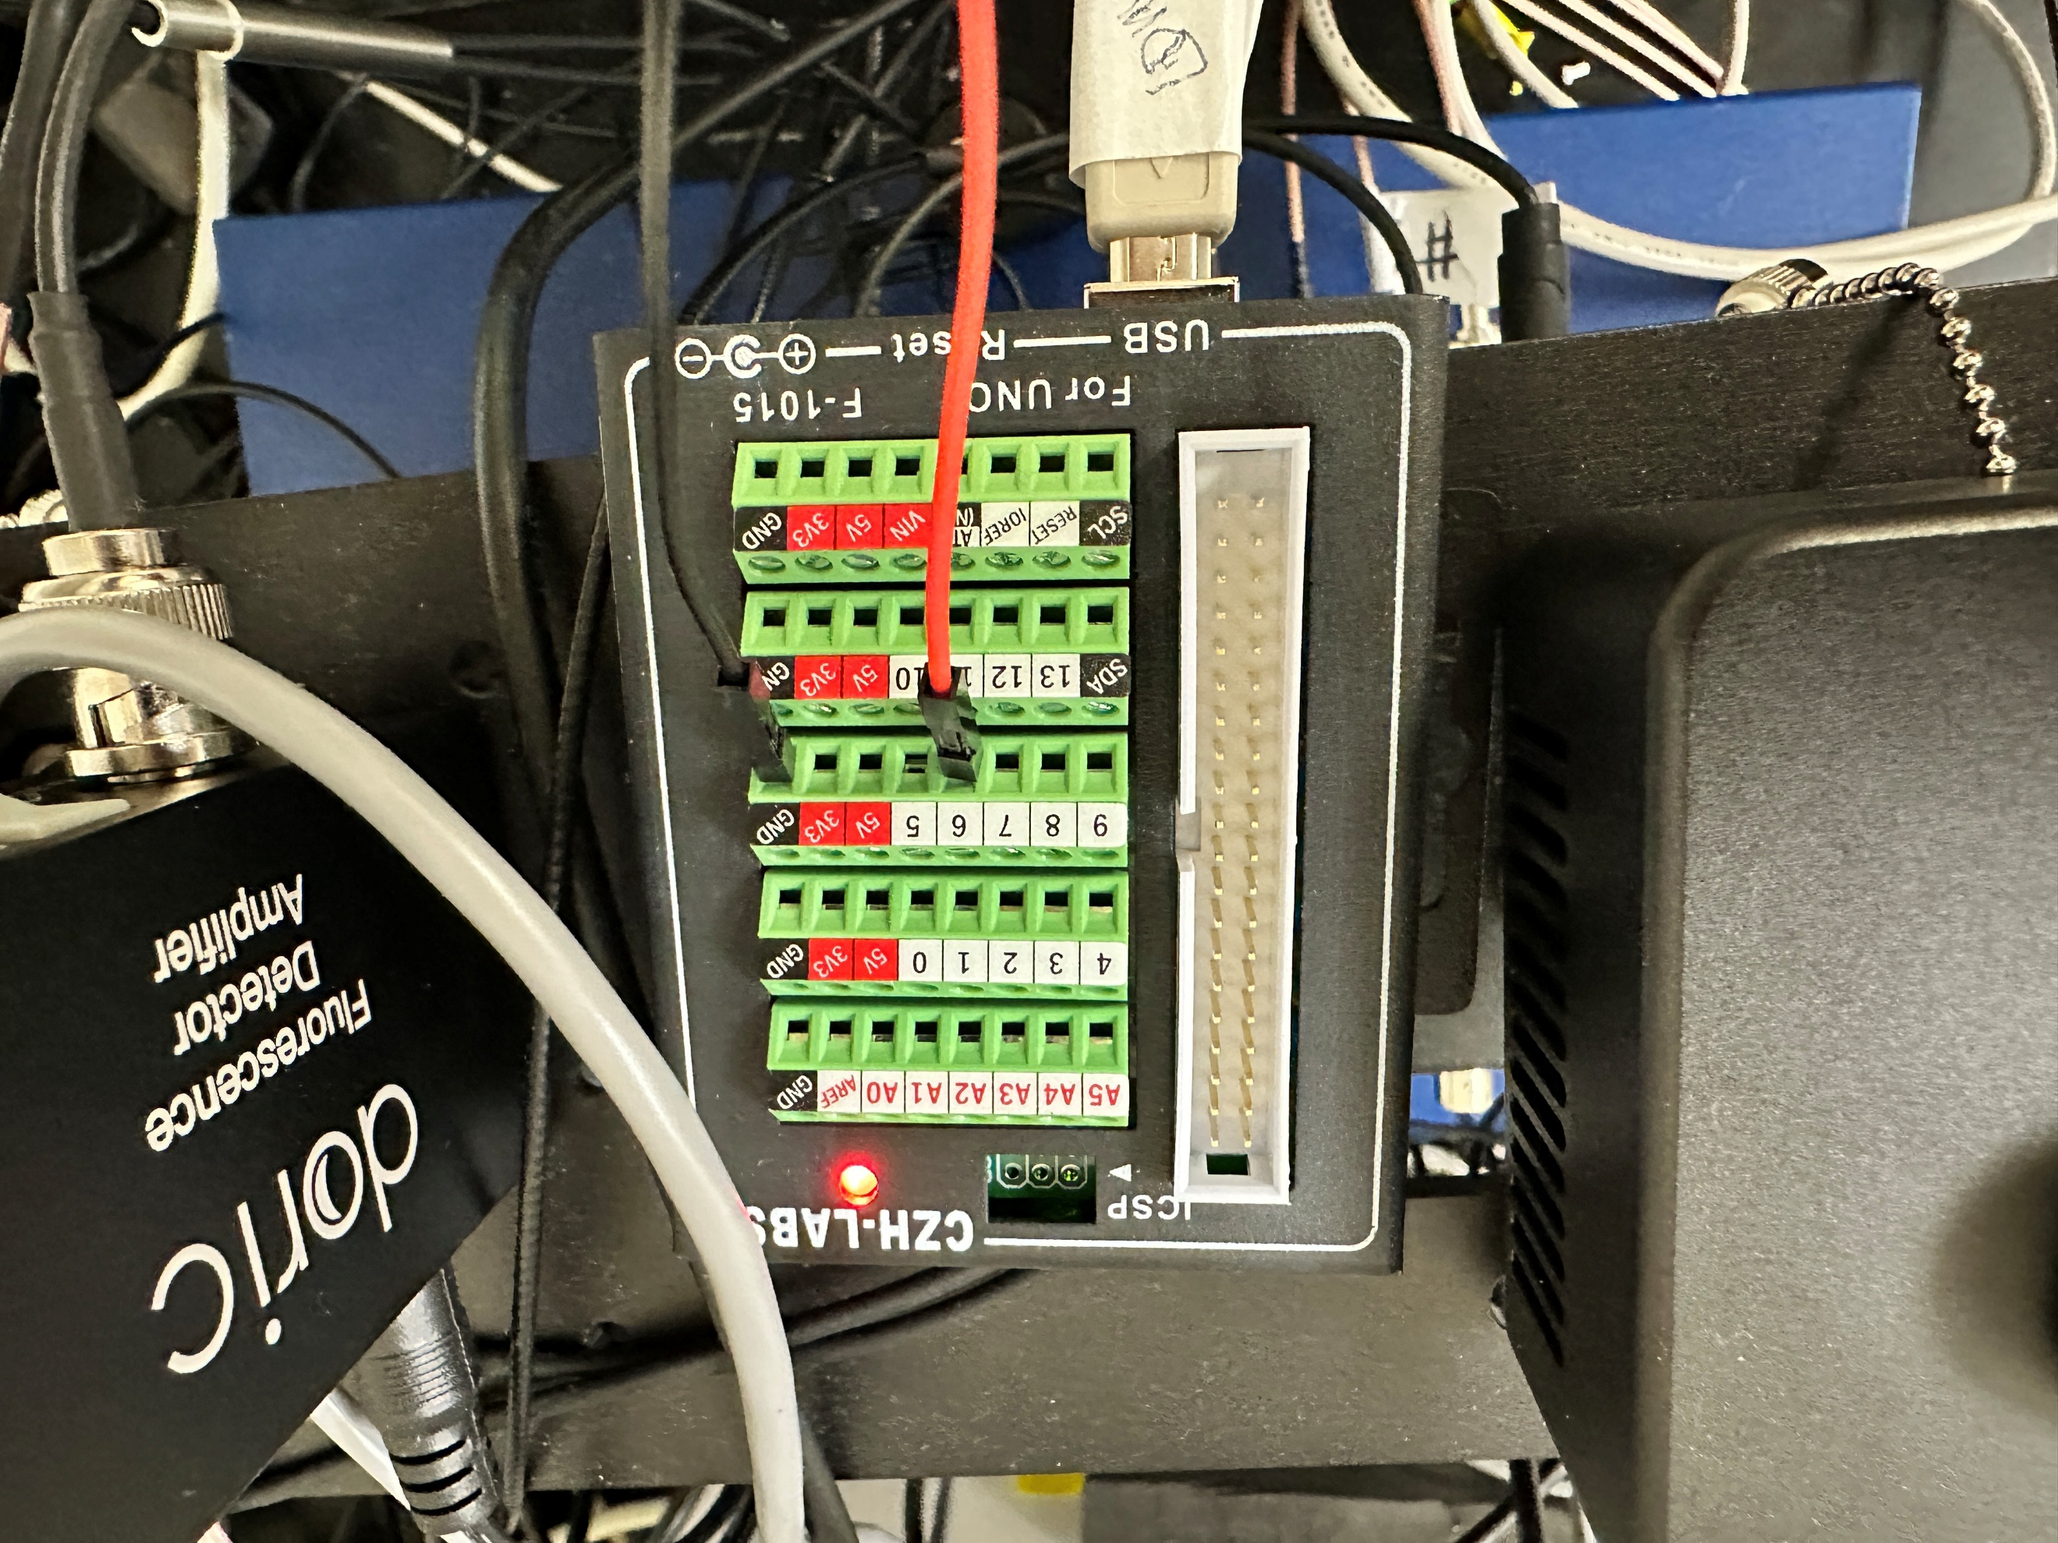
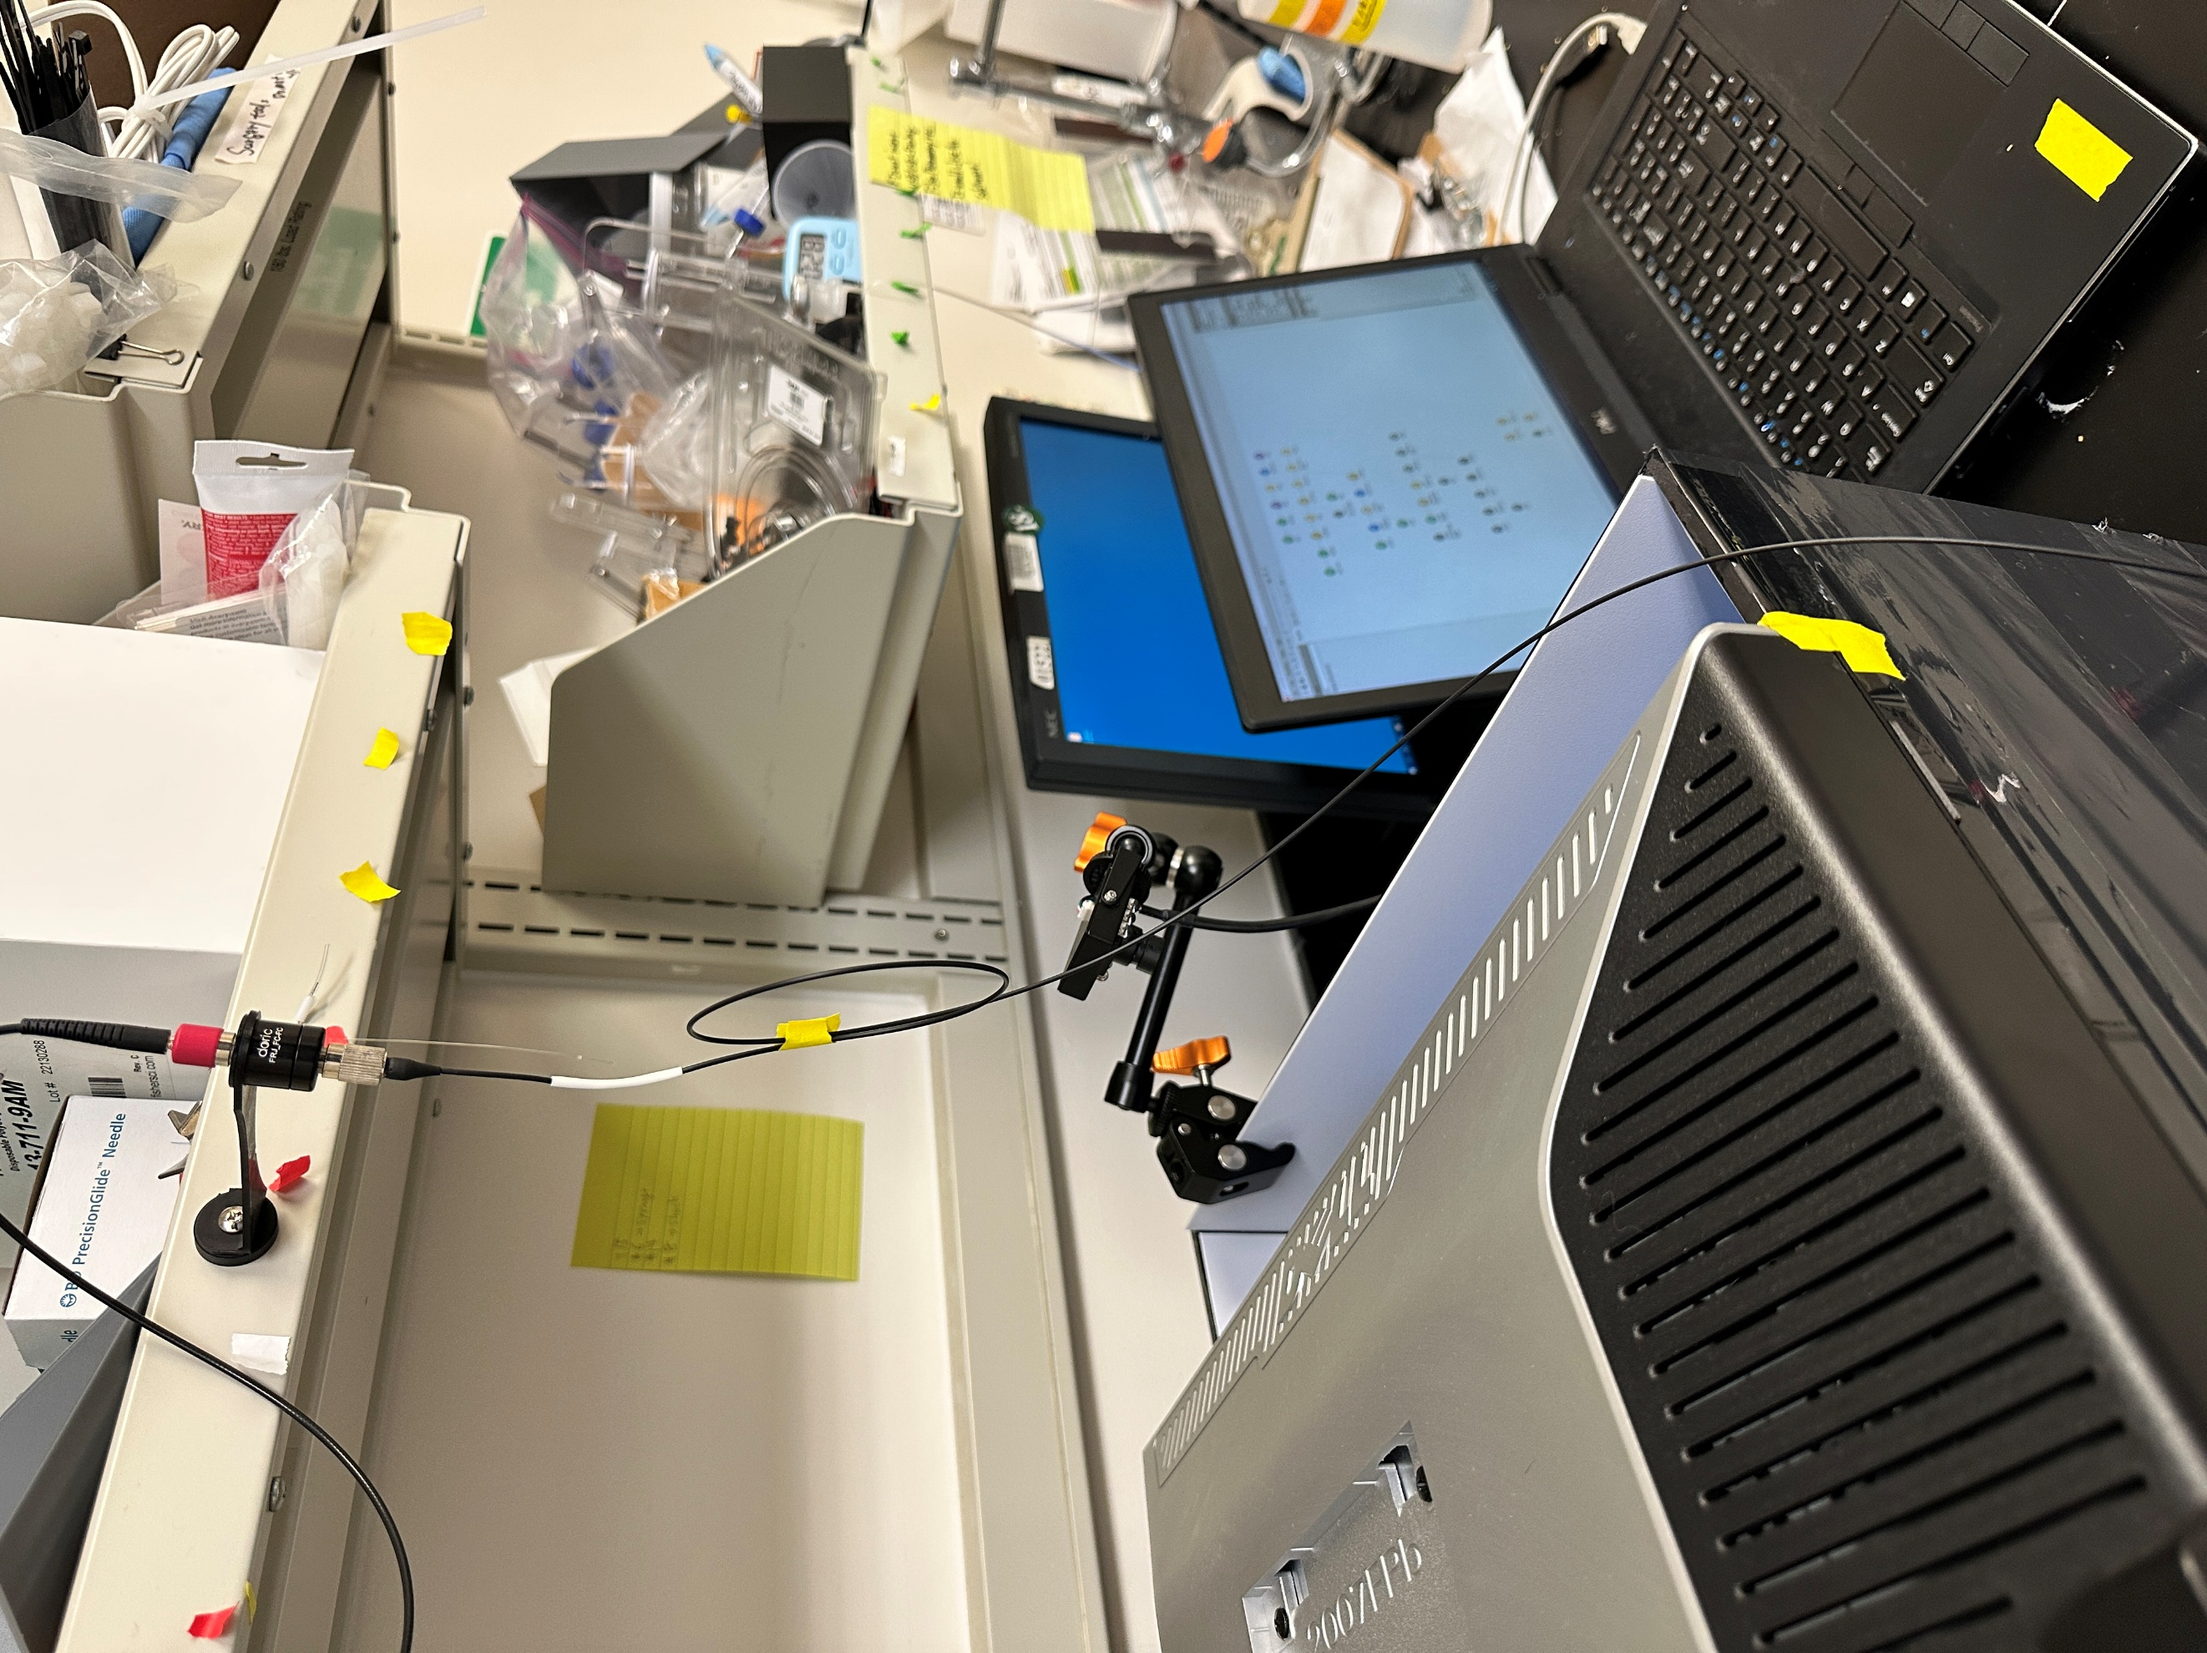
2
1
3
4
5
6

Experimental Protocol:
1. Habituate mice to the testing chamber for 3 consecutive days.
2. Behavioral Testing (2 Days, Counterbalanced Design)
- Day 1: No Optogenetic stimulation (control)
- Day 2: With Optogenetic stimulation
Note: Optogenetic stimulation begins at looming onset and is maintained throughout the remainder of the recording.
2.1 Light Source Setup
- Turn on the Doric light source (638 nm for Halo or ChrimsonR).
- Press the control knob to select “External TTL” mode.
- Adjust the knob to set the output to 79 mA (~10 mW laser power).
Note: Verify power output with a power meter as needed.
2.2 Turn on the computer and all monitors.
2.3 Open the Bonsai workflow: ZY_Loomstim_V6_manual_2020316.bonsai
2.4 Pre-recording setup:
- Run the workflow.
- If the UI does not appear automatically, open it manually.
- Set the following parameters: Data folder, User, Experiment ID, and Mouse ID
2.5 Behavioral Recording Procedure
- Place the mouse into the chamber and click “Start”.
- After a 10-minute baseline, the “start_stim” button will appear for looming stimulation.
- Deliver stimulation only when the mouse is in the corner farthest from the safety shelter.
- Recording will automatically stop 30 seconds after stimulation
Stimulation parameters:
Initial size was held at 2° for 250 ms, followed by expansion to 50° over 250 ms, then maintained at 50° for 500 ms. This sequence is repeated 10 times with an inter-stimulus interval (ISI) of 1.6 s.
3. Post-Trial Handling
- Return the mouse to its home cage.
- Clean the chamber with 70% ethanol.
- Allow the chamber to dry before testing the next mouse.

